Practical 2.2 – Logical Modelling and Normalisation

**1.Relational Schema**

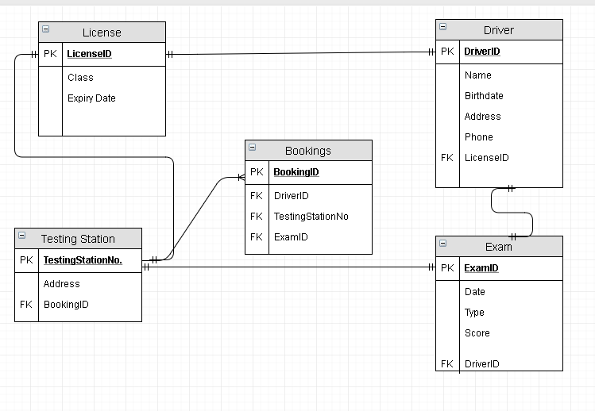

**Data Dictionary**

**Table Name: License**

|  |  |  |
| --- | --- | --- |
| **Field Name** | **Data Type** | **Constraint** |
| **LicenseID** | **Int** | **Primary Key** |
| **Class** | **Varchar** | **NOT NULL** |
| **Expiry Date** | **Number** | **NOT NULL** |

**Table Name: Driver**

|  |  |  |
| --- | --- | --- |
| **Field Name** | **Data Type** | **Constraint** |
| **DriverID** | **Int** | **Primary Key** |
| **Name** | **Varchar** | **NOT NULL** |
| **Birth Date** | **Date** | **NOT NULL** |
| **Address** | **Varchar** | **NOT NULL** |
| **Phone** | **Number** | **NOT NULL** |
| **LicenseID** | **Int** | **Foreign Key** |

**Table Name: Testing Station**

|  |  |  |
| --- | --- | --- |
| **Field Name** | **Data Type** | **Constraint** |
| **TestingStationNo** | **Int** | **Primary Key** |
| **Address** | **Varchar** | **NOT NULL** |
| **BookingID** | **Int** | **Foreign Key** |

**Table Name: Bookings**

|  |  |  |
| --- | --- | --- |
| **Field** | **Data Type** | **Constraint** |
| **BookingID** | **Int** | **Primary Key** |
| **DriverID** | **Int** | **Foreign Key** |
| **TestingStationNo** | **Int** | **Foreign Key** |
| **ExamID** | **Int** | **Foreign Key** |

**Table Name: Exam**

|  |  |  |
| --- | --- | --- |
| **Field** | **Data Type** | **Constraint** |
| **ExamID** | **Int** | **Primary Key** |
| **Date** | **Number** | **NOT NULL** |
| **Type** | **Varchar** | **NOT NULL** |
| **Score** | **Int** | **NOT NULL** |
| **DriverID** | **Int** | **Foreign Key** |

**2.Schema**

**1NF**

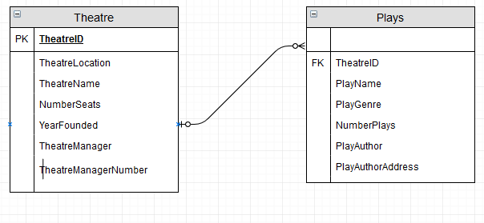

**2NF**

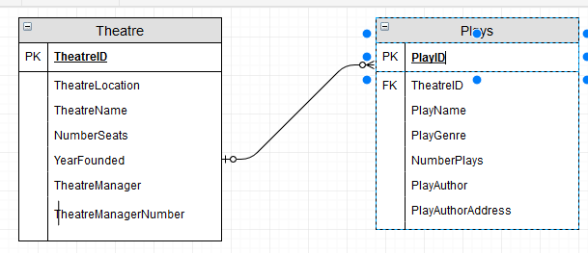

**3NF**

